less command: used to read the contents of a text file one page at a time it does not access the complete file but access page by page.

less filename

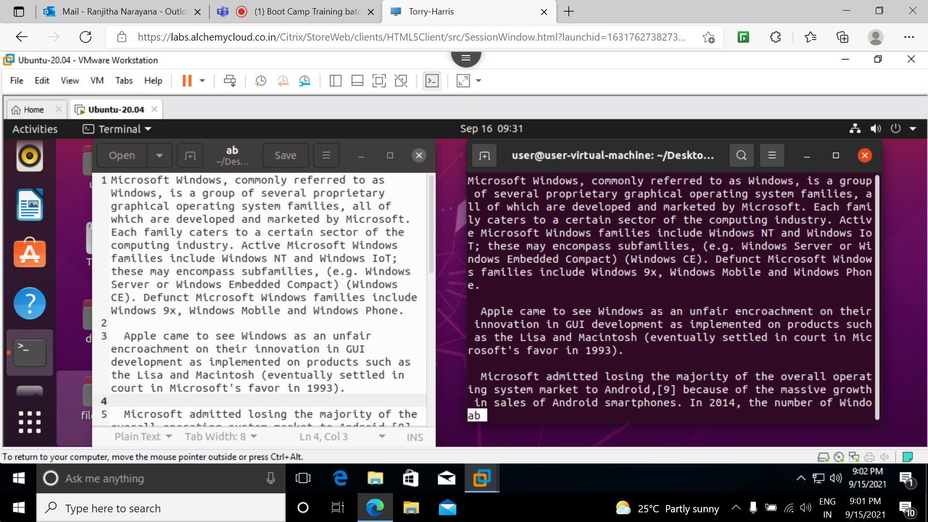

less -p “ “ filename: it tells less to start at the first occcurence of pattern in the file.

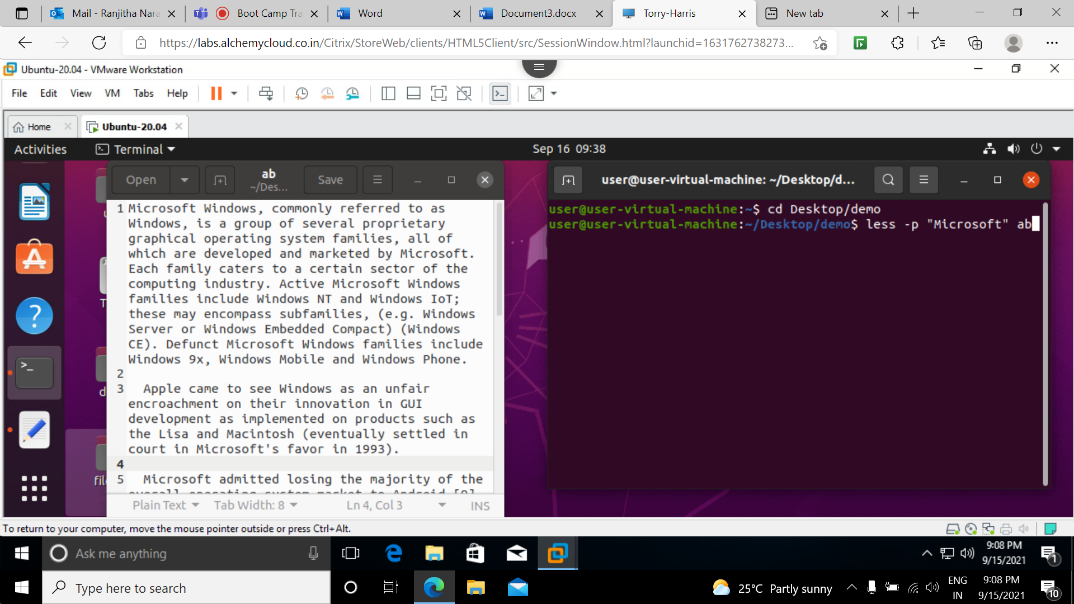

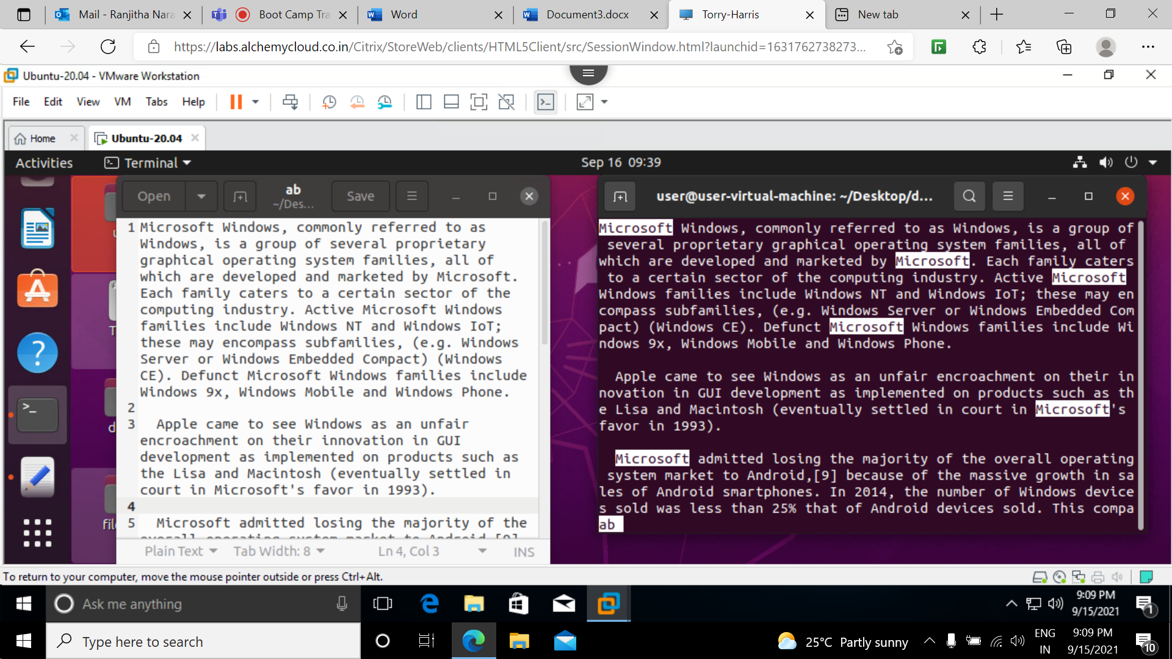

less -N filename: suppresses the line numbers

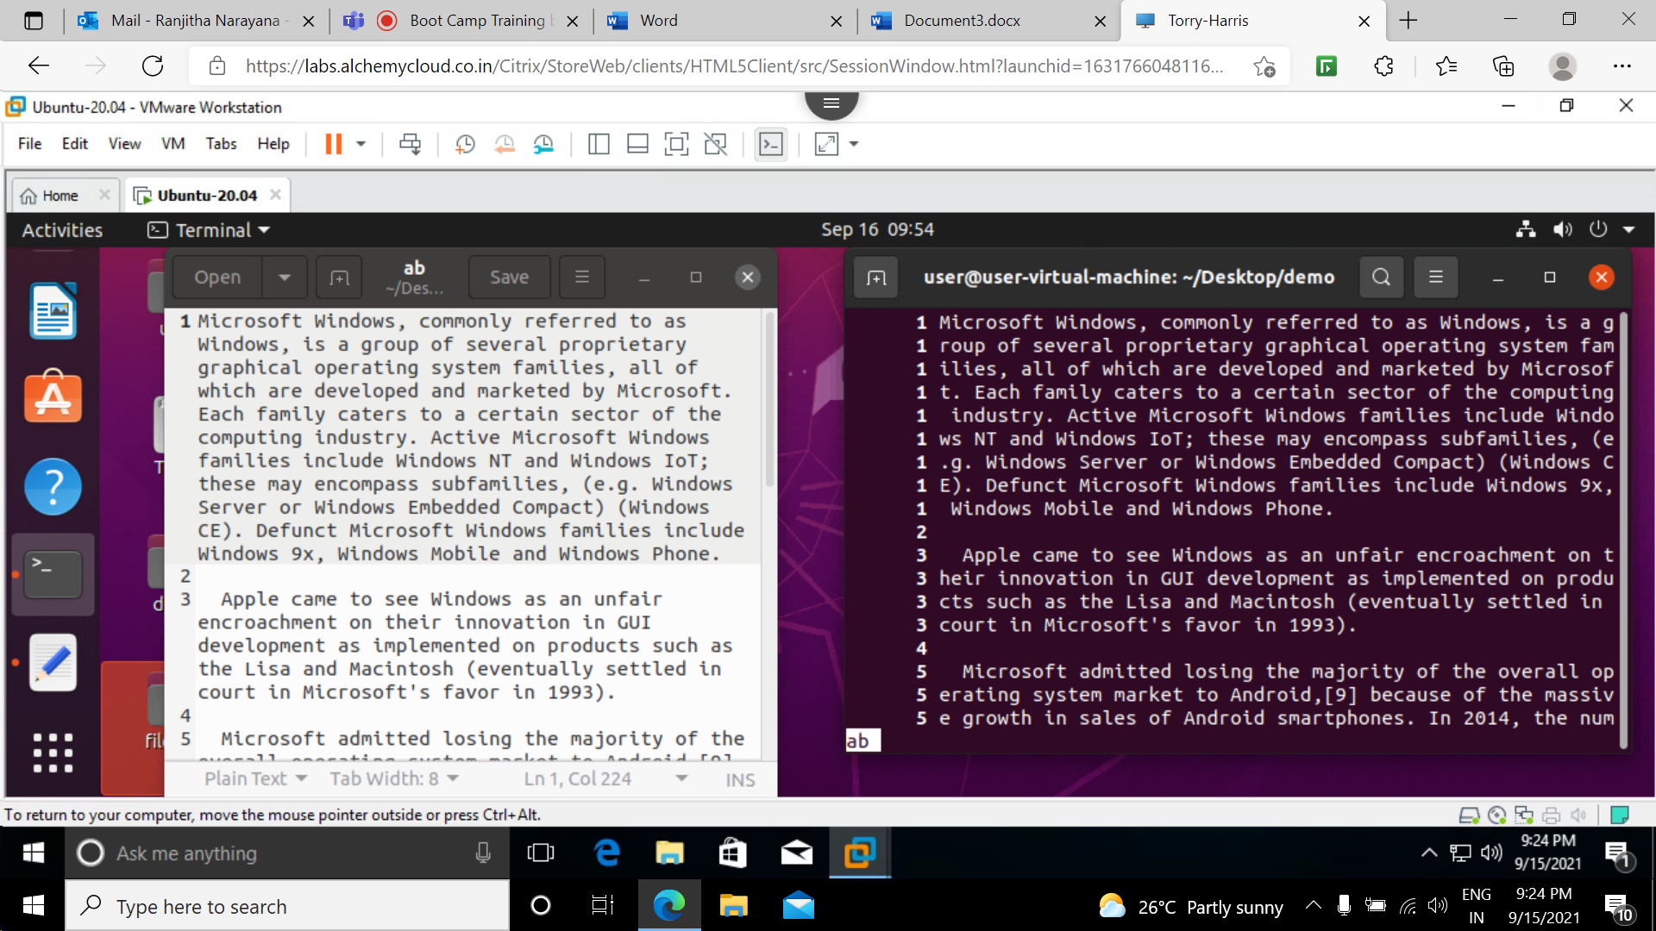

Vim command: It is a advanced text editor for text editing

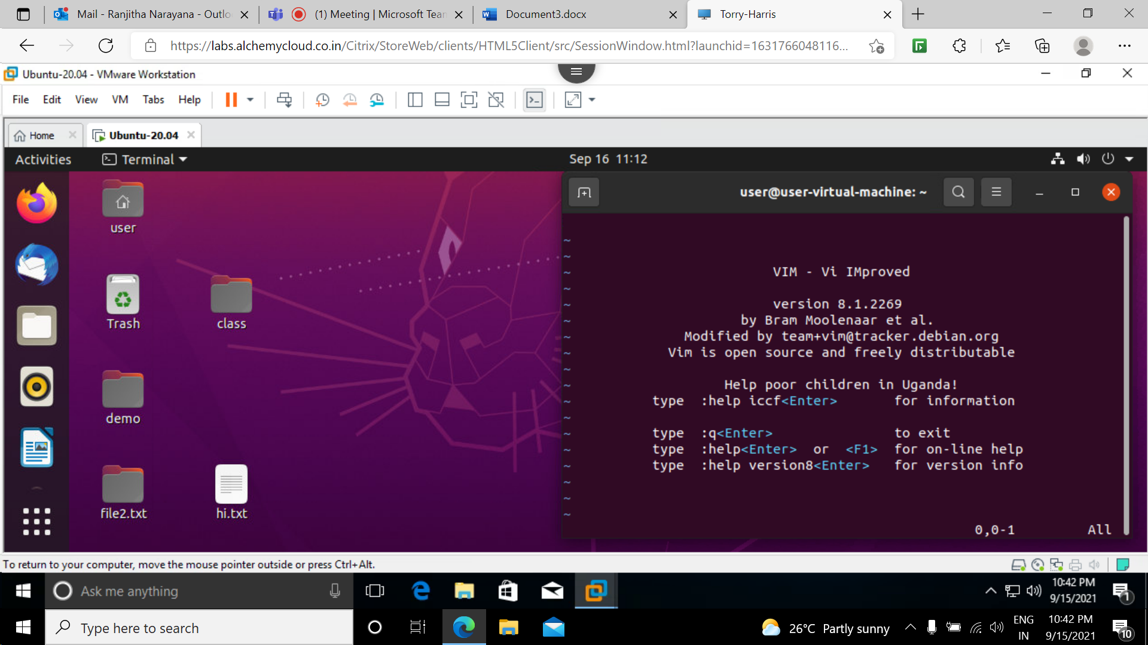

i a A keys :used to insert any text .

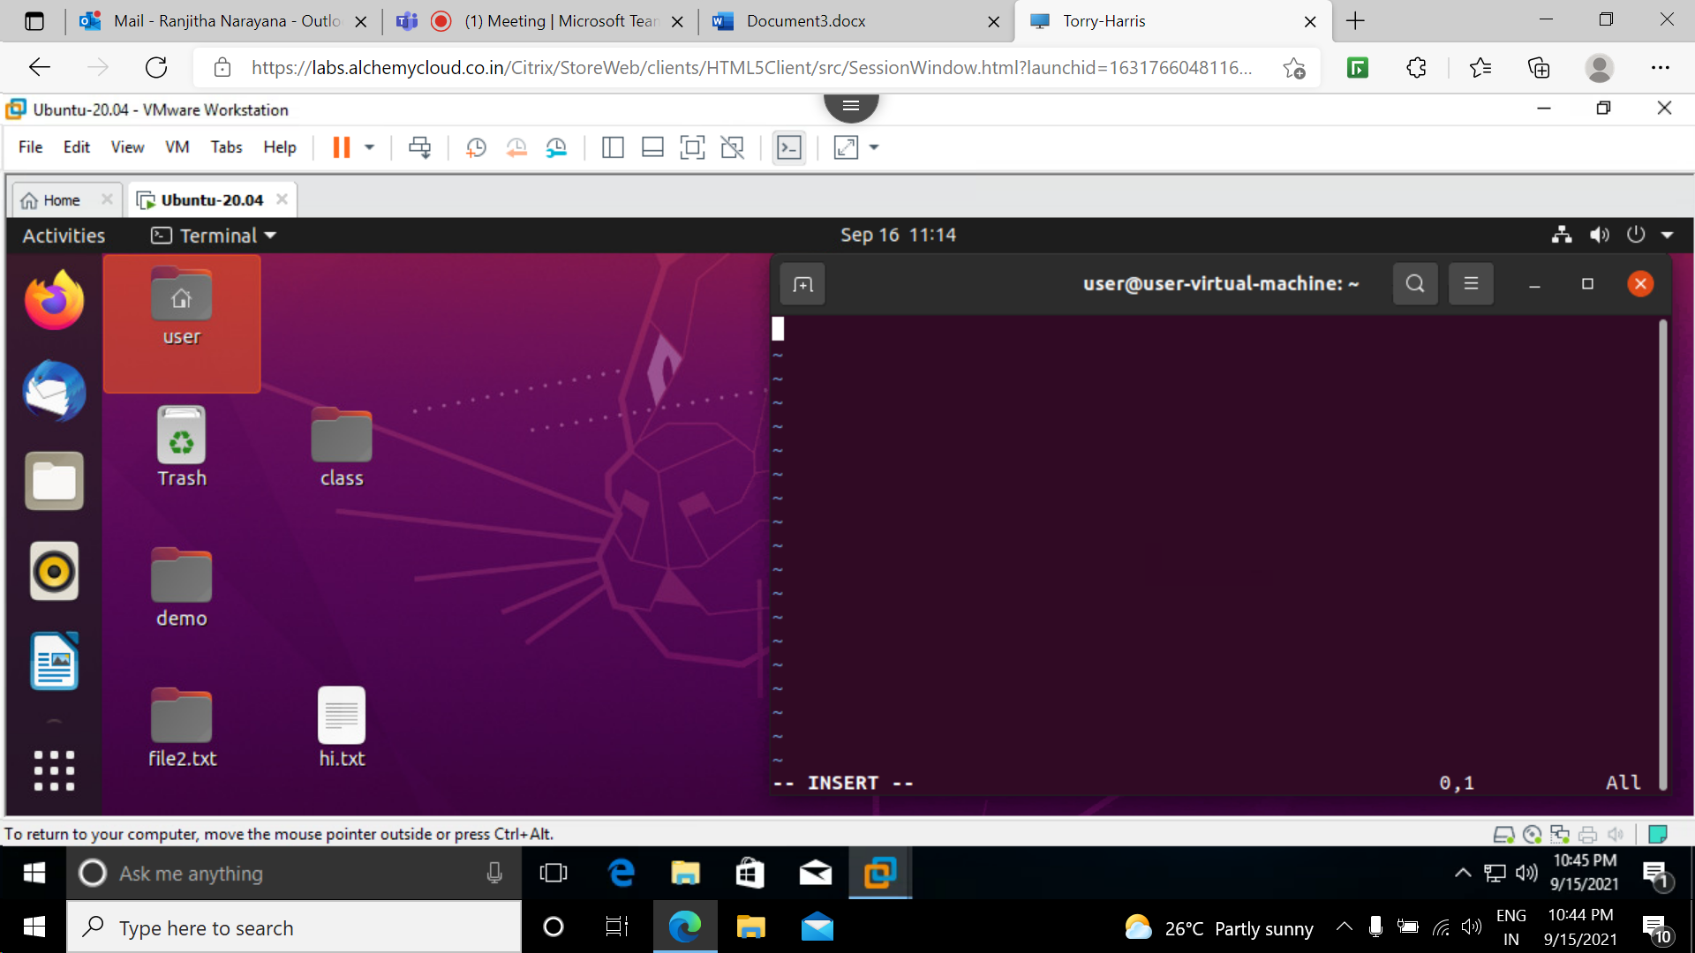

:w filename : used to save the file

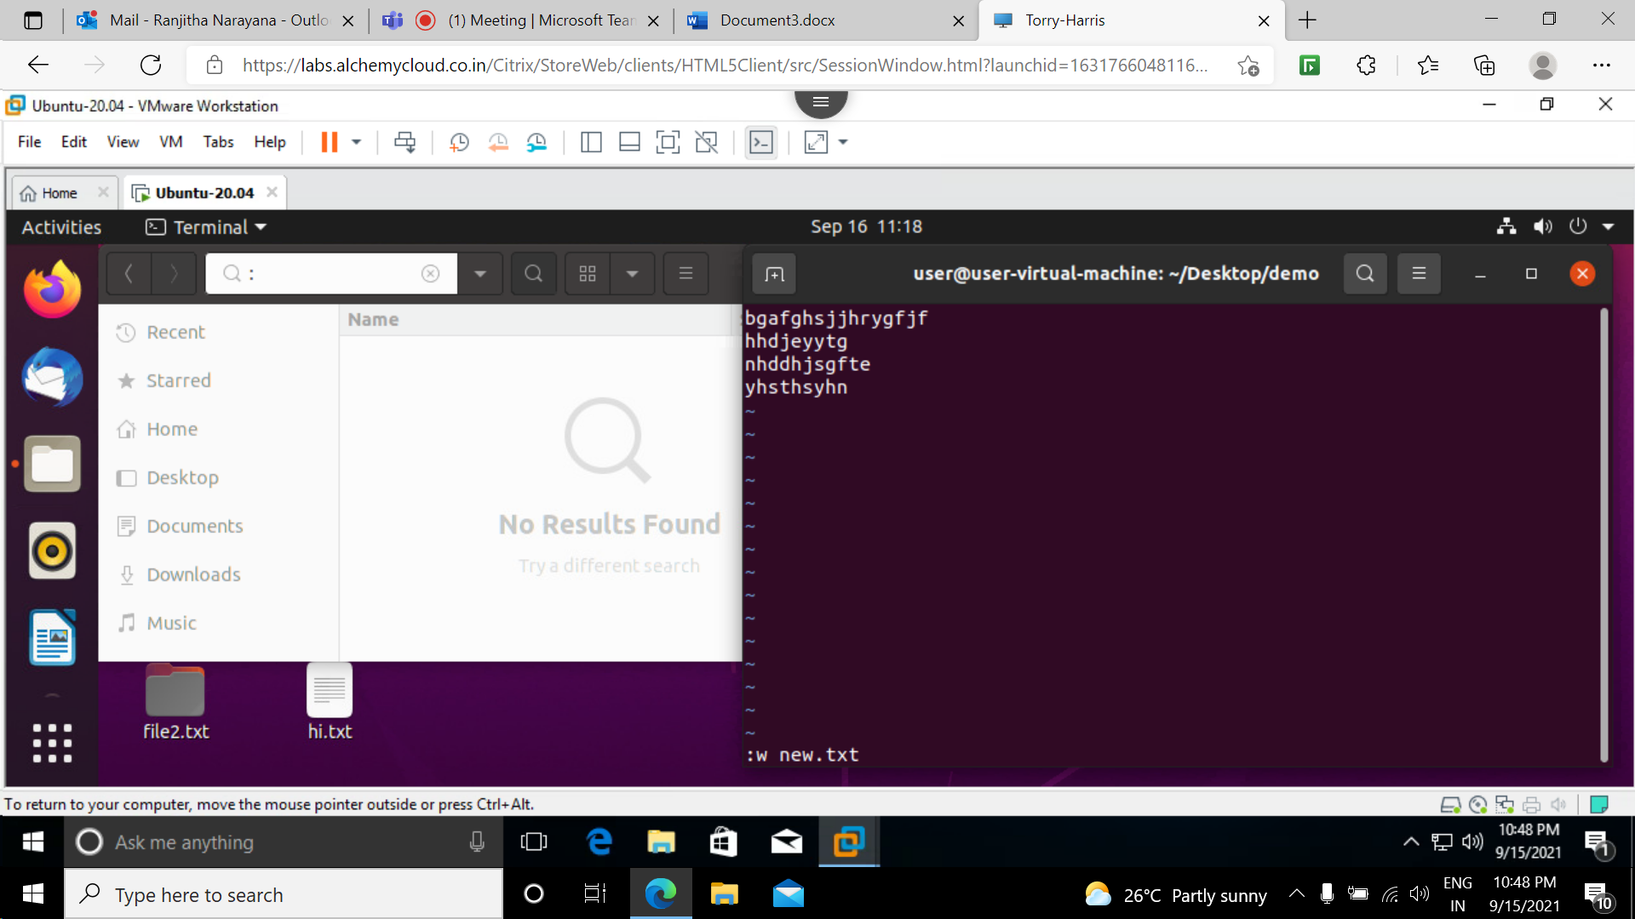

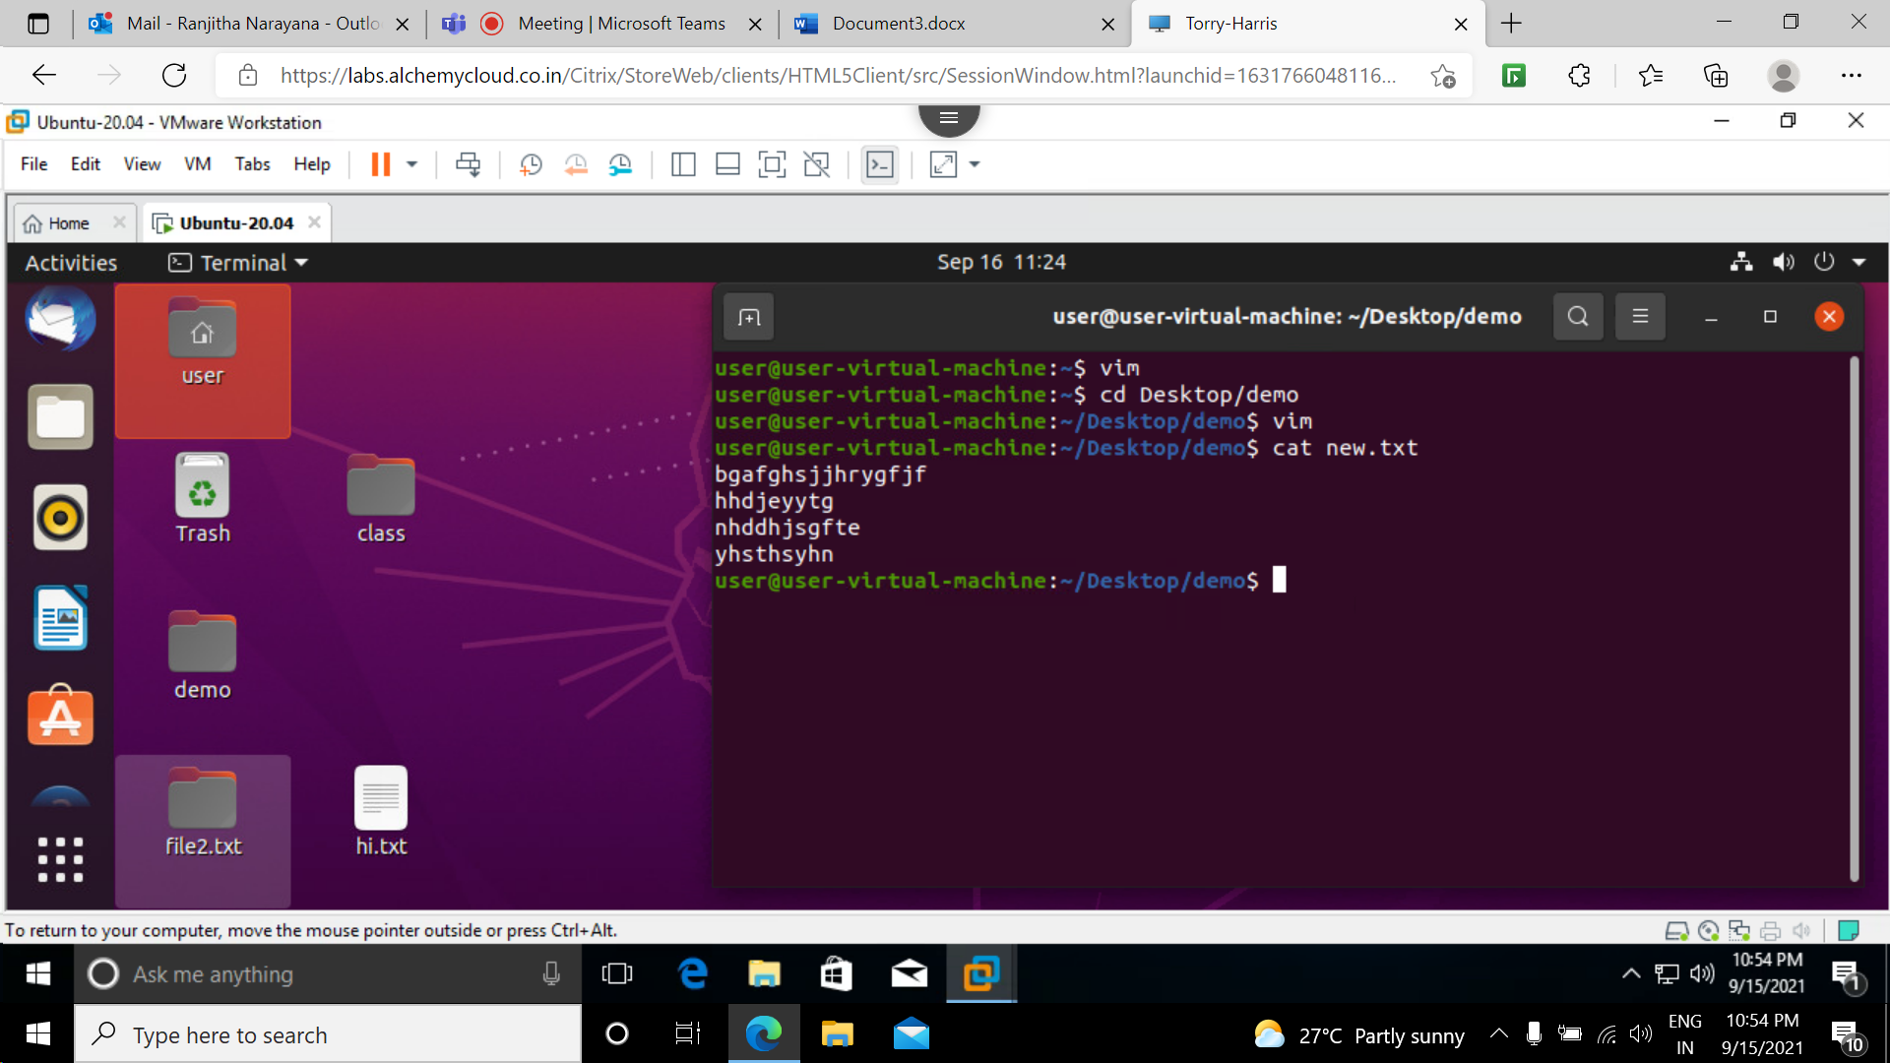

: r filename : used to copy the file text

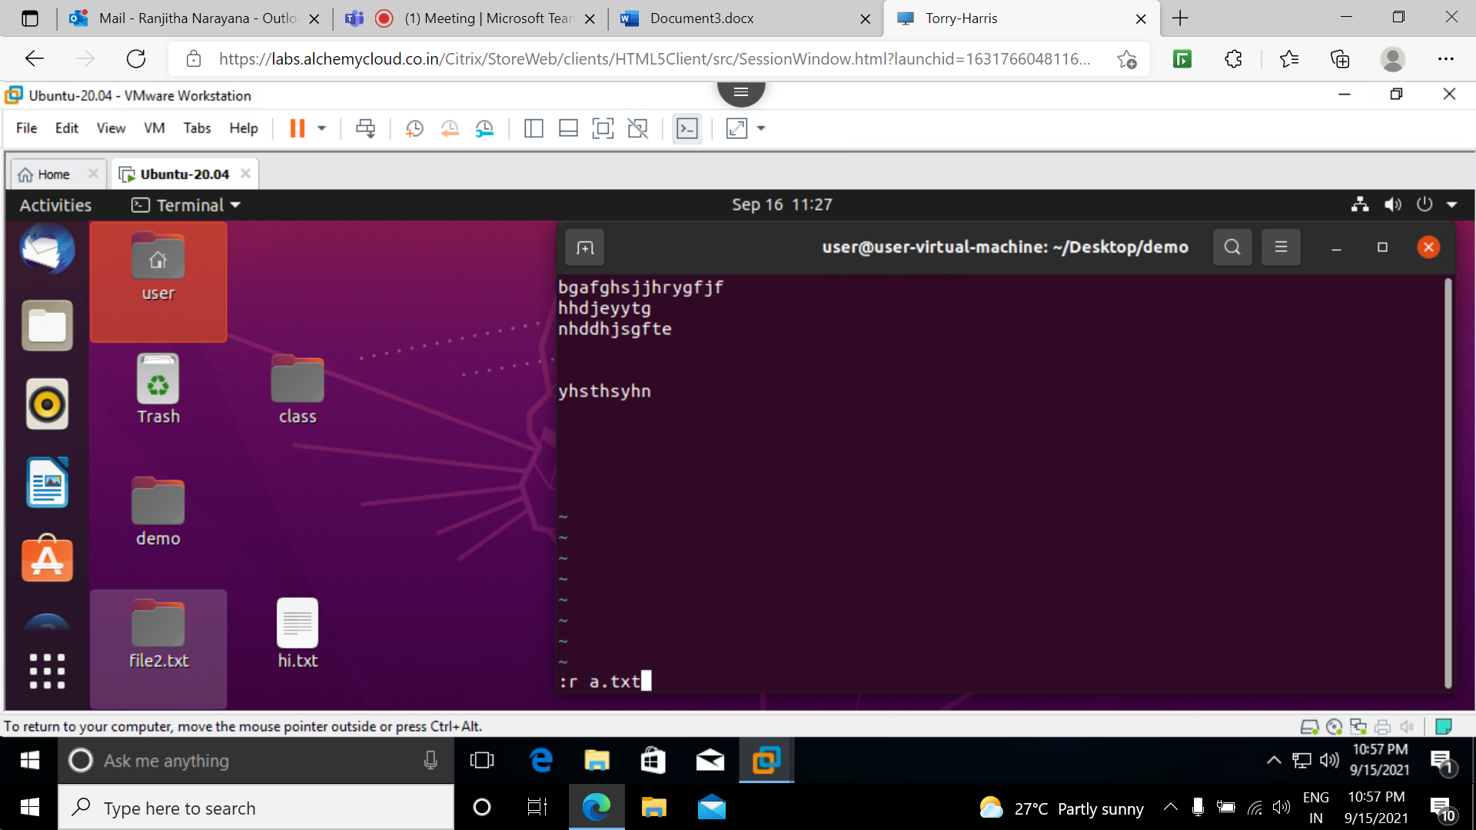

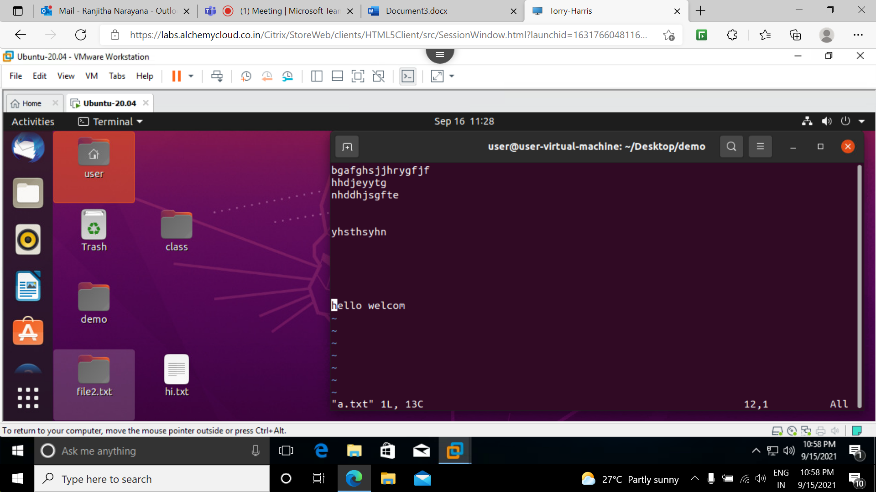

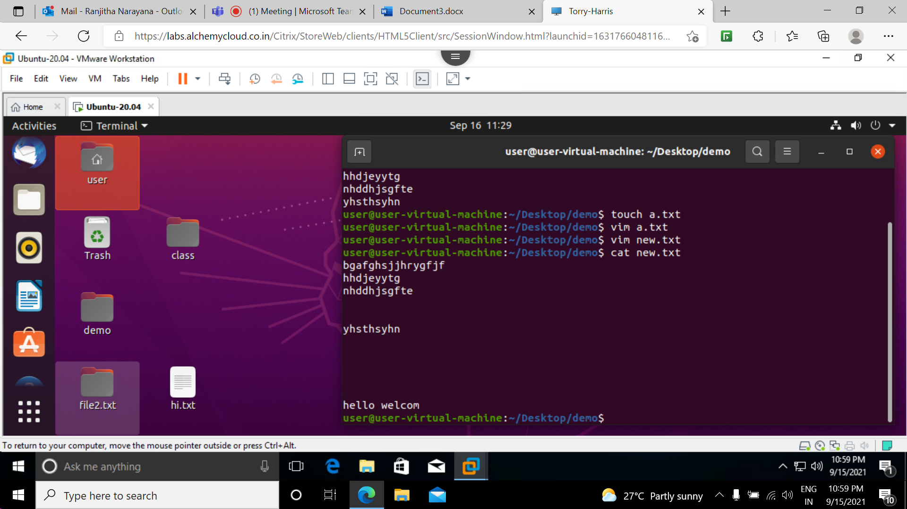

X key is used to delete the word letter by letter.

dd key is used to delete the current line where the cursor is

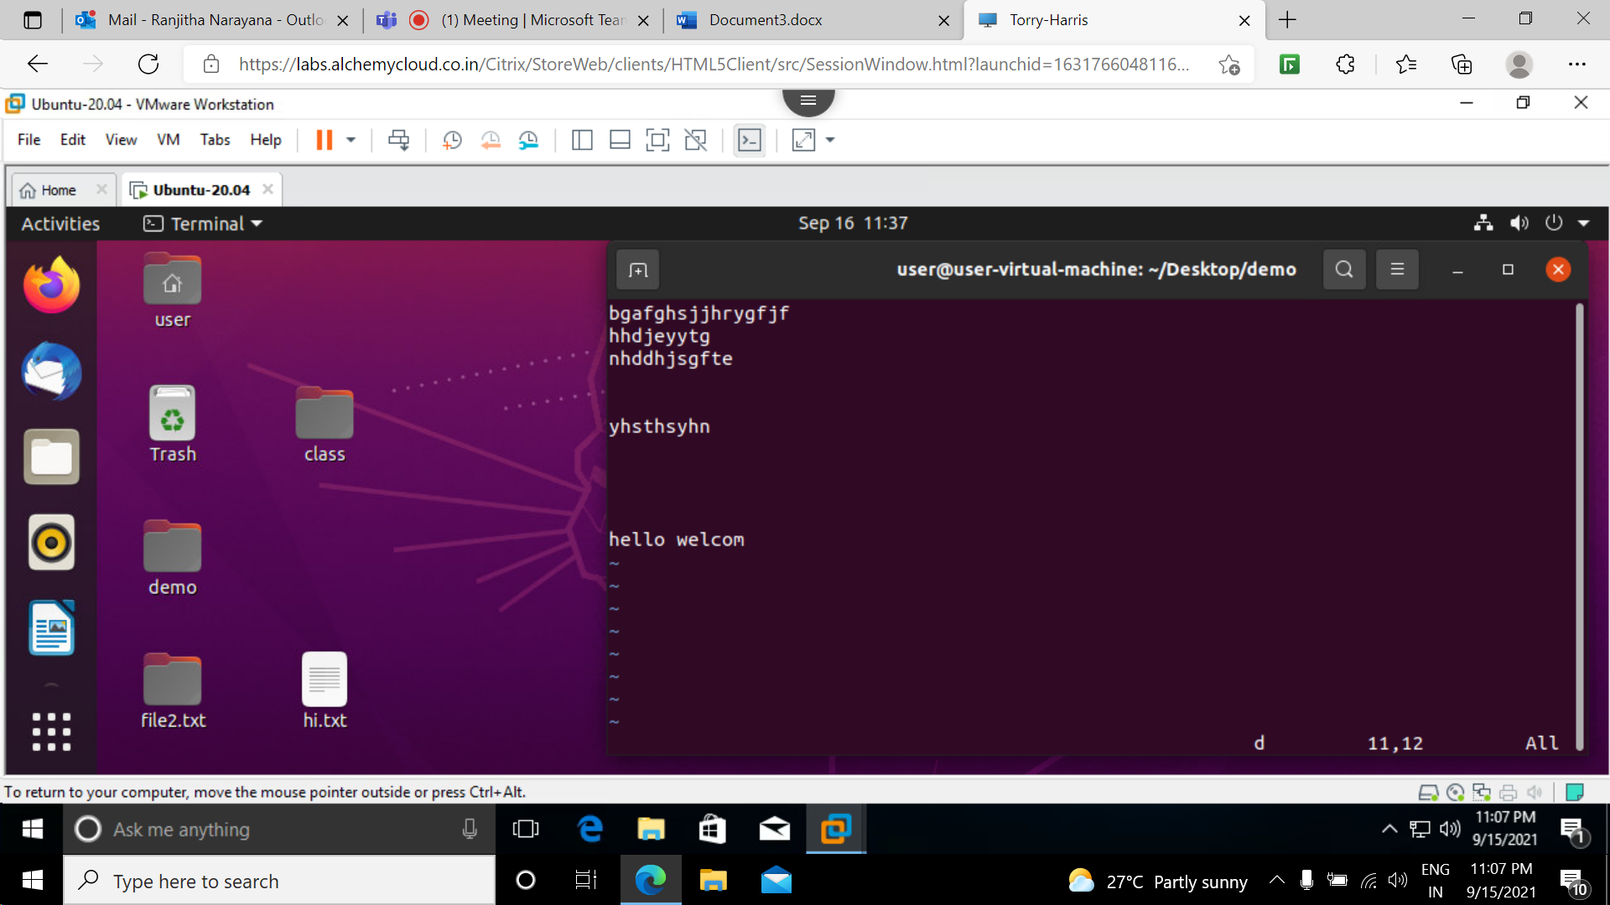

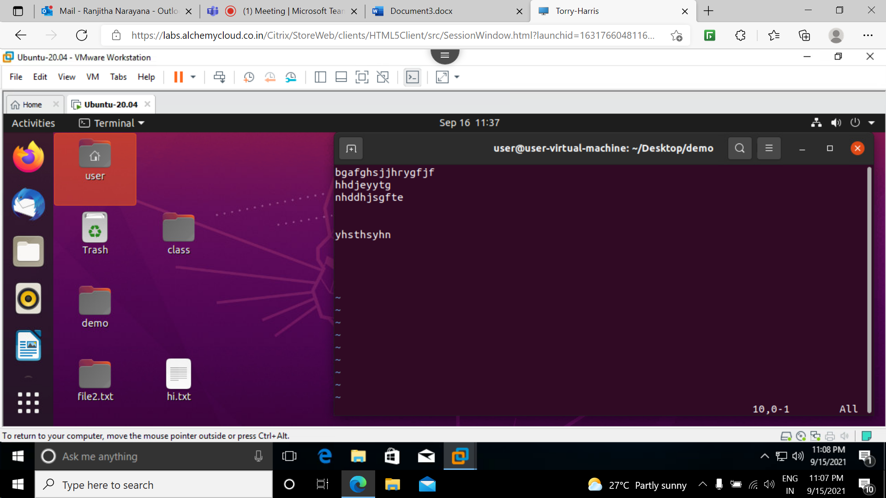

U key is used to undo

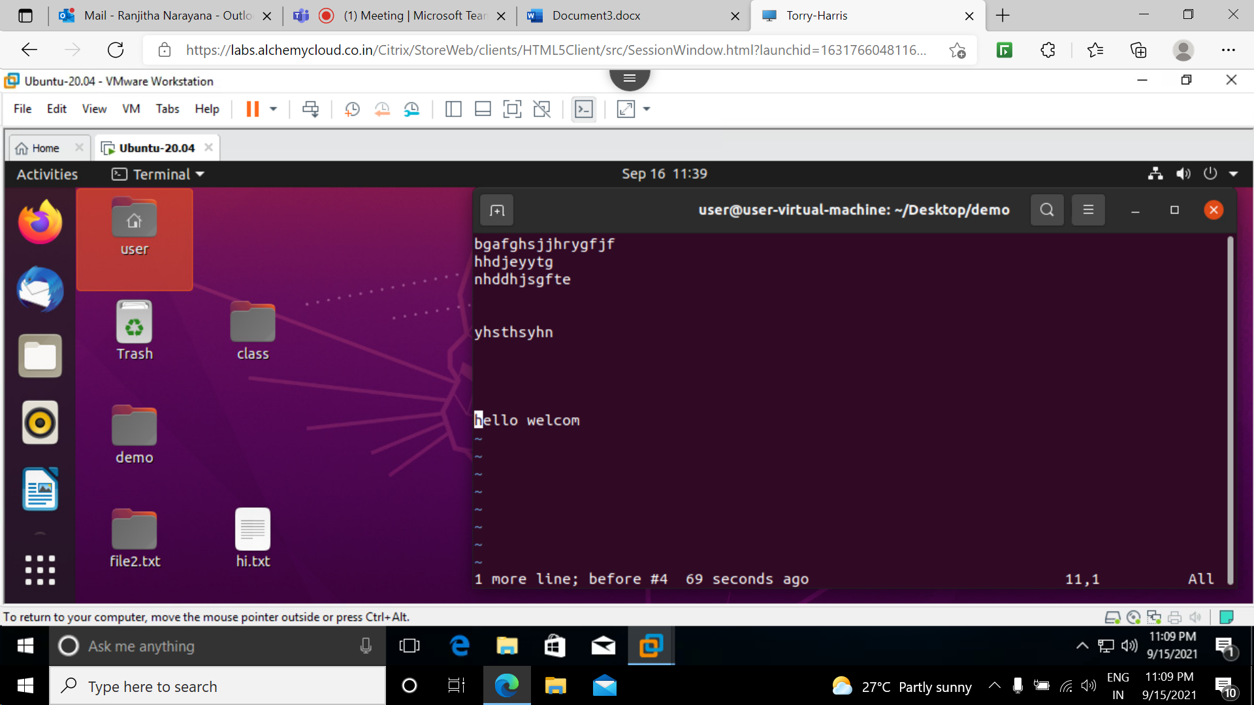

:wq is used to save and exit .

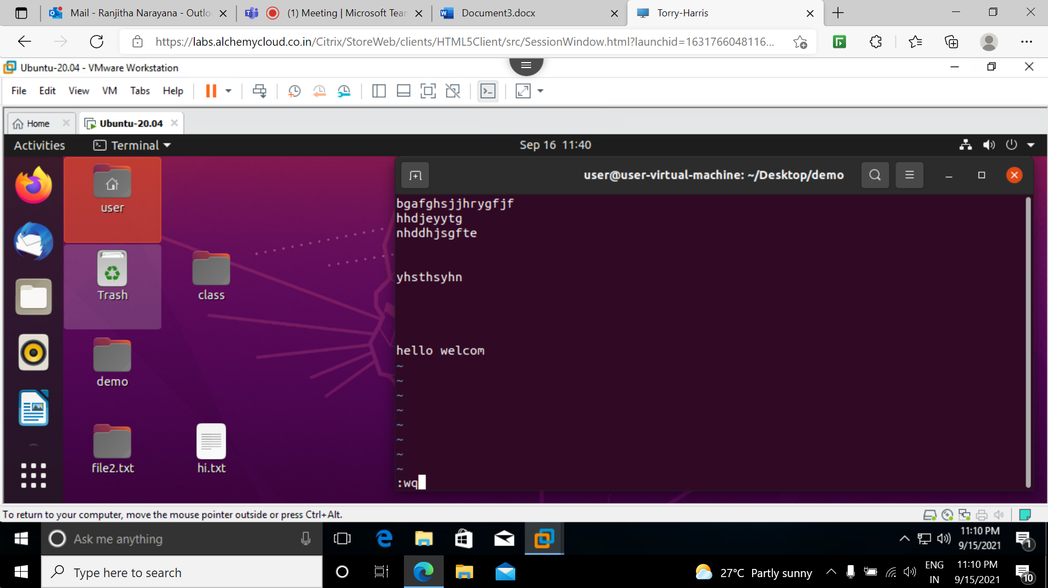

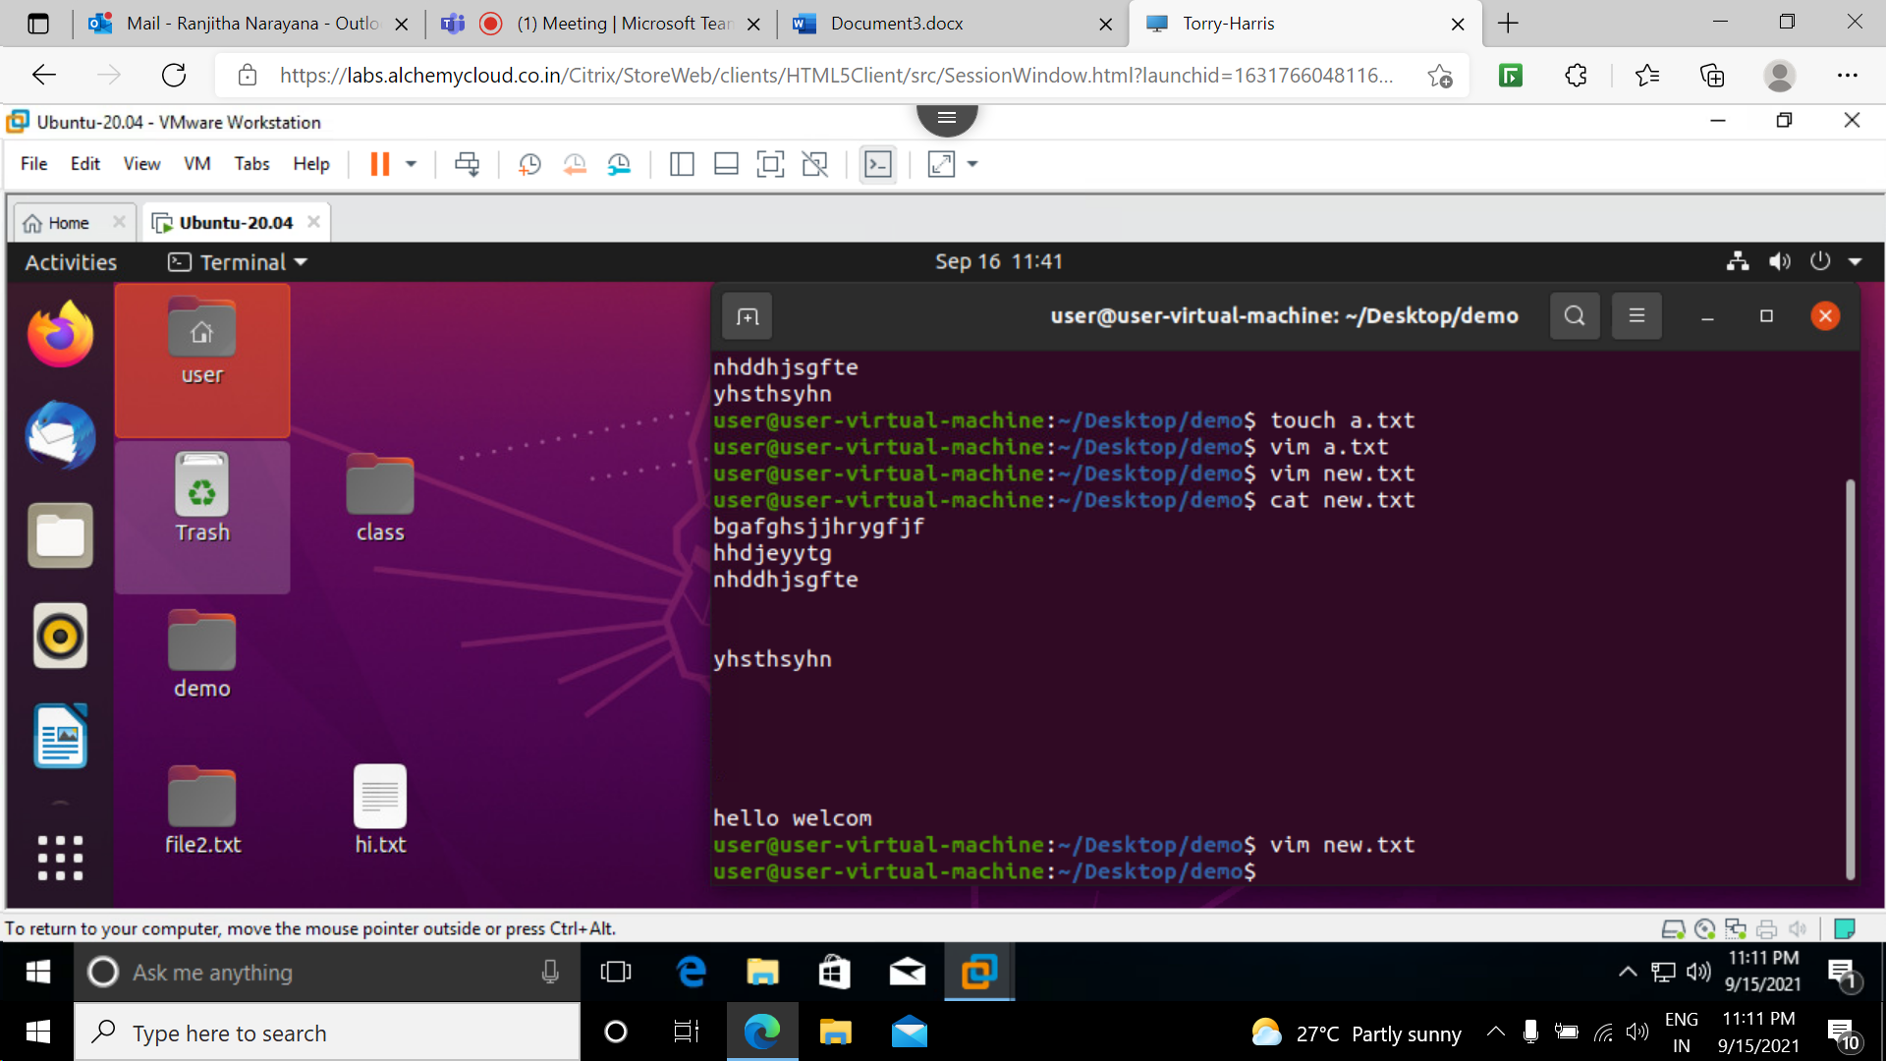

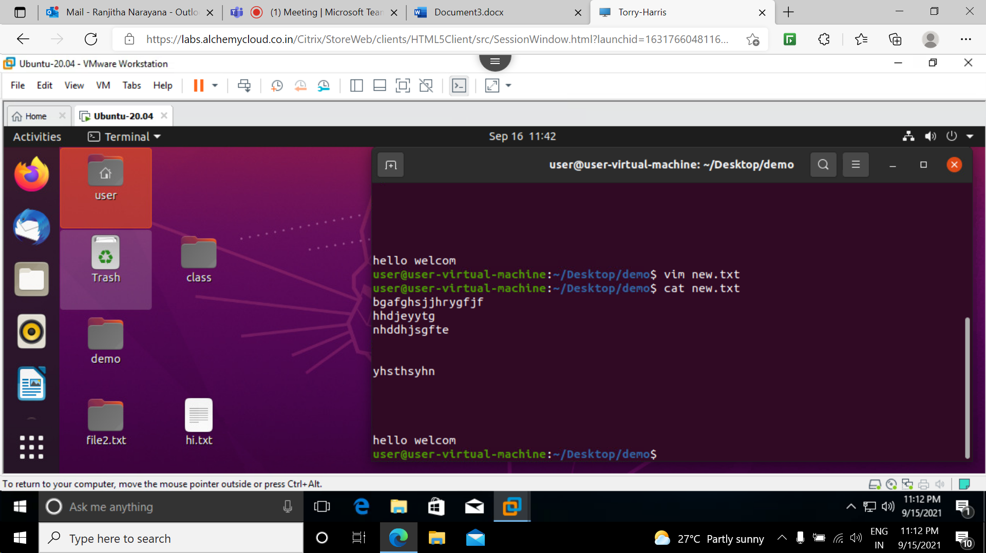

:q! is used to exit but it does not saves the txt we edited 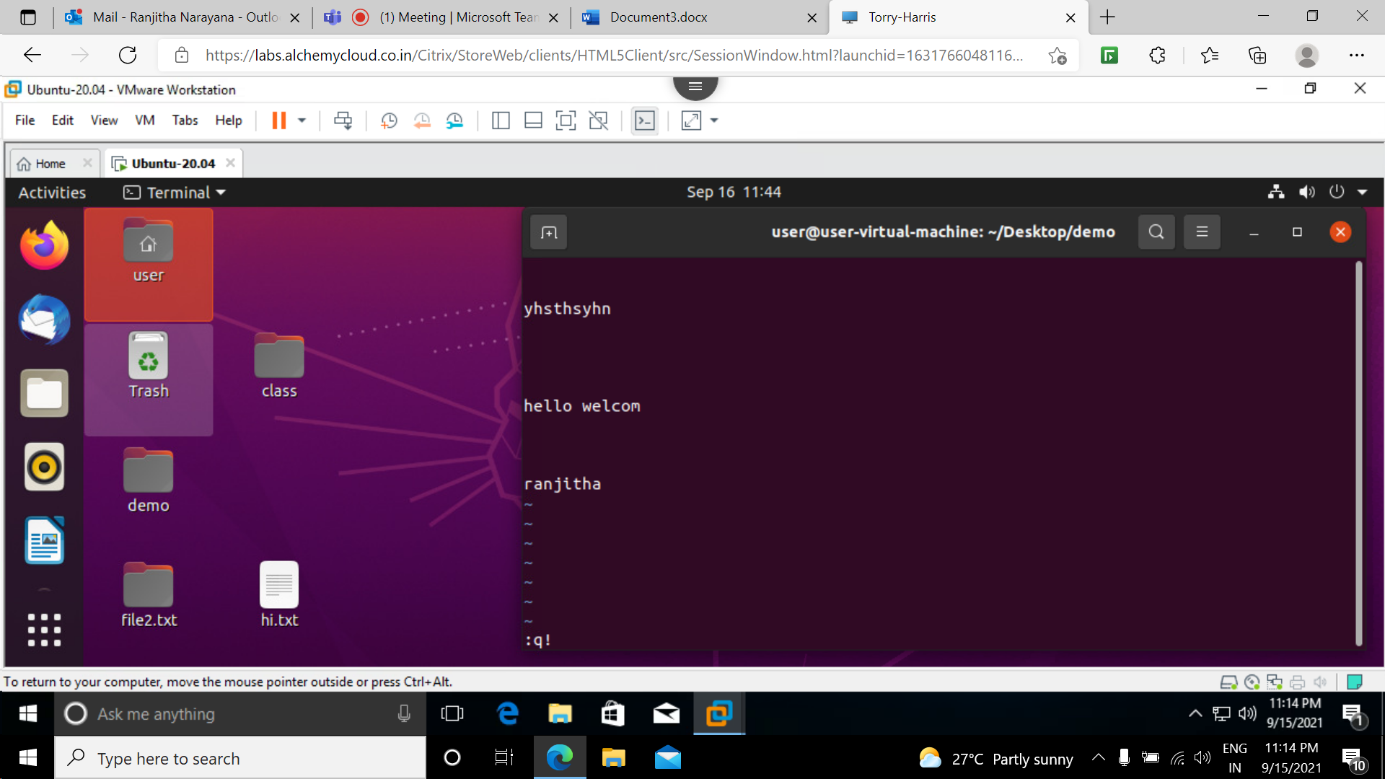

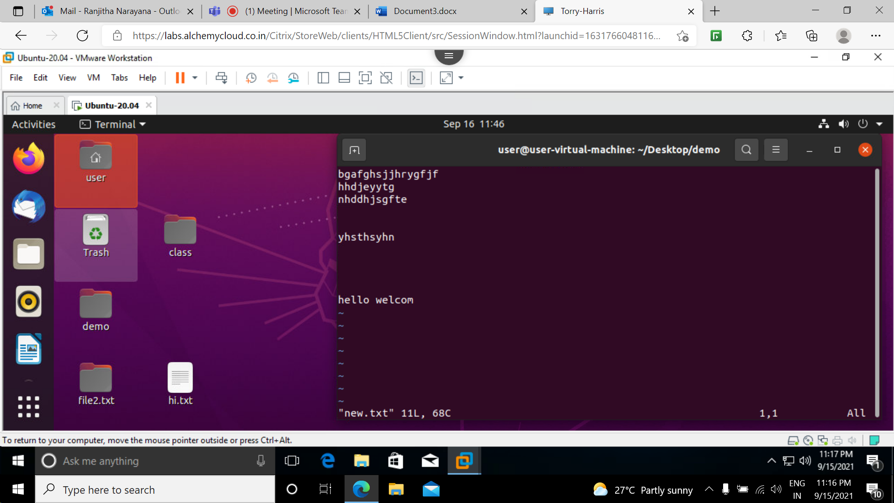

Head command: print the top N number of data of the given input bu default it prints first 10 lines of the file.

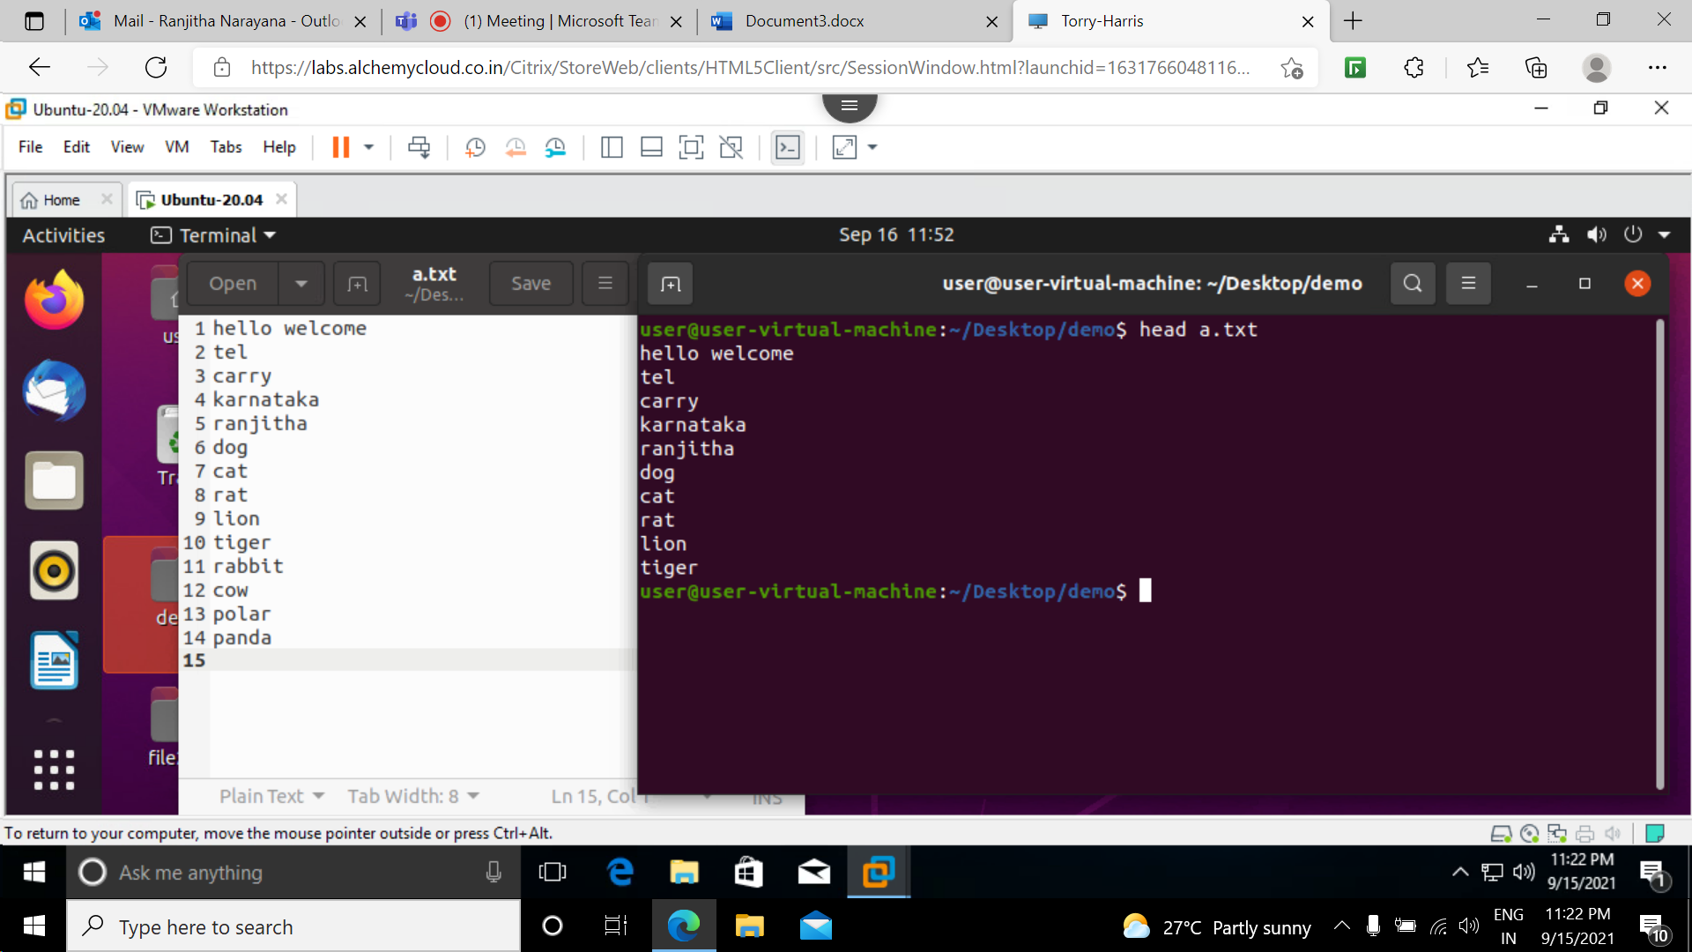

-n :prints the lines mentioned instead of 10 lines

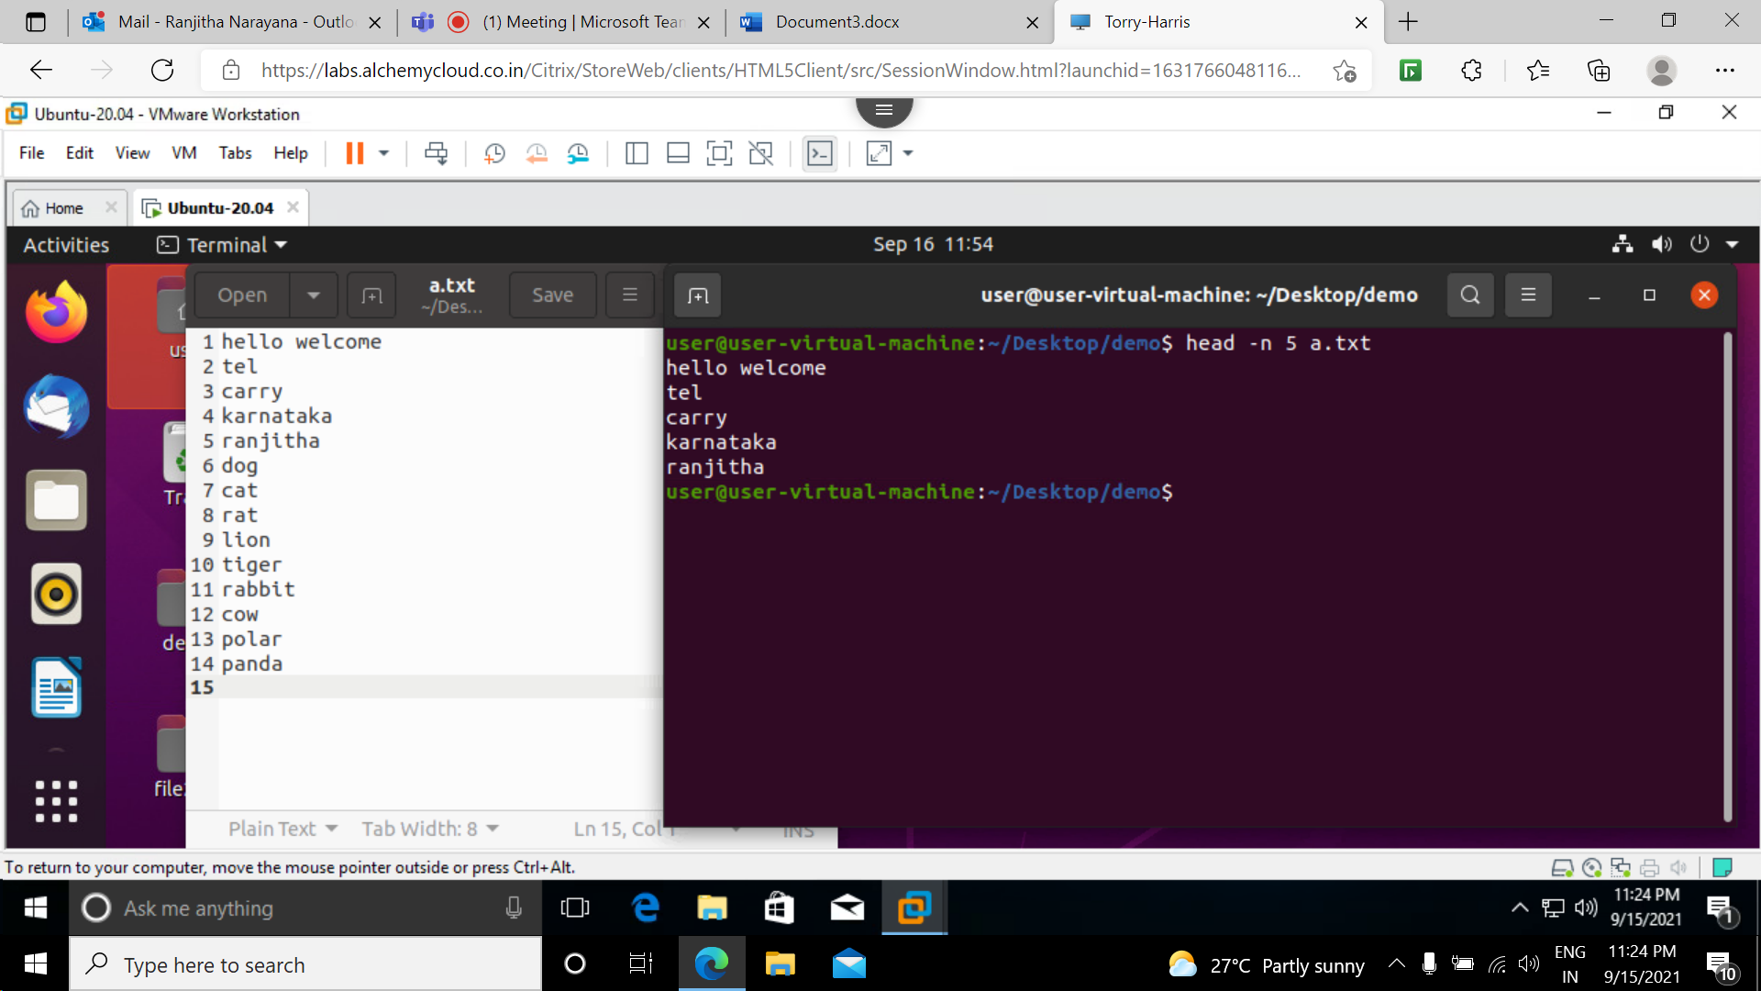

-c : prints the first num bytes from the file specified. newline count as a single character so if head prints out a newline it will count it as a byte

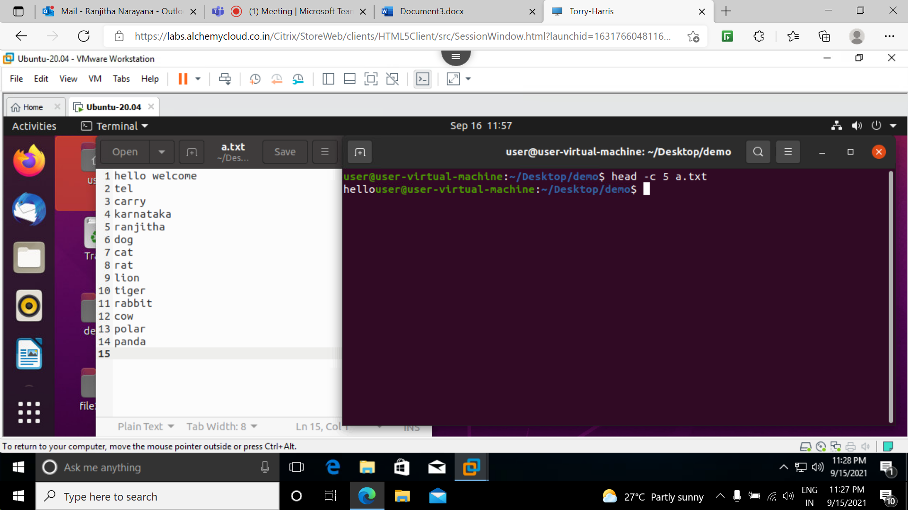

-q : used if more than 1 file is given data from each file is not precedes by its file name.

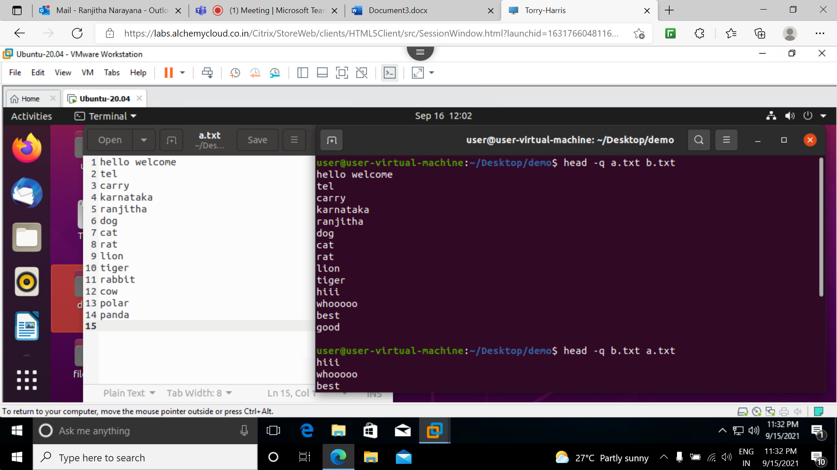

-v : by using this option data from the specified file is always preceded by its file name.

